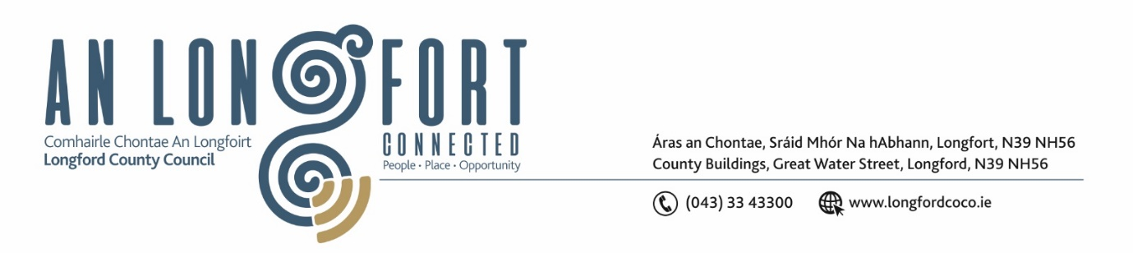

***Please note meeting will be held in the Council Chamber and via Microsoft Teams.***

7 July 2022.

**Chuig: Gach Ball don Chomhairle.**

A Chomhairleoir,

Iarrtar ort bheith i láthair ag Cruinniú Míosuil Chomhairle Chontae Longfoirt a tionólfar i Seomra na Comhairle, Aras an Chontae, Longford agus via MS Teams are an **Chéadaoin 13ú Lúil 2022 ag** **4pm** chun gnó a dhéanamh d’réir an Chláir thíos.

You are requested to attend the Monthly Meeting of Longford County Council to be held in the Council Chamber and **via Microsoft Teams** on **Wednesday 13 July 2022 at 4pm** to transact business, as set out on the Agenda hereunder.

Mise le meas,

*Ann Marie Mc Keon*

**__________________**

**Ann Marie Mc Keon**

**Meetings Administrator.**

**C L Á R**

Prayer before meeting.

**1.** Confirmation of Minutes of Monthly Meeting of Longford County Council held on 8 June 2022– copy enclosed.

**2.** Matters Arising.

**3.** Declaration of Interest by Members.

**4.** To note Management Report – enclosed.

**5.** To note adopted Minutes of Corporate Policy Group Meeting held on the

10 May 2022 – enclosed.

**6. Infrastructure, Housing and Innovation**

**(a)** Rural Water Multi-Annual Programme 2022-2025.

**(b)** Notice of Motions, submitted by Councillors, as listed hereunder –

**Councillor Paul Ross**

“I request that a review of the management of all the roundabouts in our county is

undertaken to bring them up to a standard that reflects the values and positive promotion of our county as they are a shop window to the county”.

**7. Finance and IT**

**(a)** To note Report of the Local Government Audit Services 2021 – Report enclosed.

**(b)** Consideration of Approval of Loan funding of €2,000,000 to part finance various Urban & Rural Regeneration Projects.

**(c)** Consideration of the disposal of property (shared ownership scheme) at Aughamore, Clonbroney, Ballinalee, Longford in accordance with the terms of Section 183 of the Local Government Act 2001 as issued on the 29 June 2022.

**8. Planning and Project Delivery**

**(a)** To note Planning Applications received since last meeting of the Council.

**(b)**  Approval to the appointment of Mr. Enda Mc Manus Revamp to replace Michael

Reilly on the Climate Action and Planning Strategic Policy Committee.

**(c)** Notice of Motions, submitted by Councillors, as listed hereunder –

**Councillor Seamus Butler**

That due to the recently published 2022 Census information that Co Longford has increased its population by 14% since 2016, I propose that we revisit our current Co Development Plan in regard residential housing zones and any other parameters that are related to population growth’

**9. Community, Corporate and Enterprise**

**(a)** Approval to the appointment of Ms. Deirdre Orme, nominee of the County Longford Tourism Committee to replace Mr. Bartle D’Arcy as a member of Longford Local Community Development Committee (LCDC).

**(b)** Draft Polling Scheme 2022, Public Consultation.

**(c)** Appointment of elected representative to LAMA Committee.

**10. General**

**(a)** Notice of Motions, submitted by Councillors, as listed hereunder –

**Councillor Paul Ross**

I call on the Minister for Transport and the NDLS reinstate the walk-in service for people who wish to renew their driving license as the current appointment service is proving very difficult who do not understand the appointment service.

**Councillor Peggy Nolan**

(i) I call on Longford County Council to write to the HSE requesting that they provide the upgraded equipment and maintenance budget that was promised to be put in place at the Radiology Department at Longford Clinic, with immediate effect and that they also provide an ultra-sound facility to compliment the current maternity service on site.

(ii) I call on Longford County Council to write to Iarnrod Eireann in the interest of public safety to ensure the continuous of current services at Longford Railway station and firmly request the return of full services with immediate effect.

**11.**  **Training – enclosed.**

**12. Votes of Sympathy**